### Importing USD File into a Database

**Access PHPMyAdmin:**

* Log in to your cloud database server where PHPMyAdmin is available.

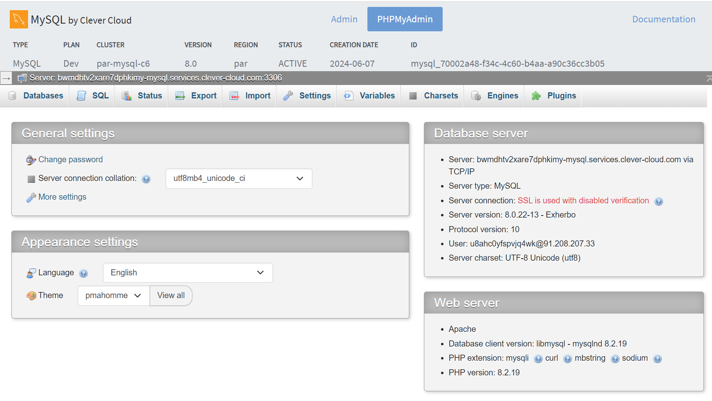

**Select Database:**

* Navigate to the database where you want to store the USD file.

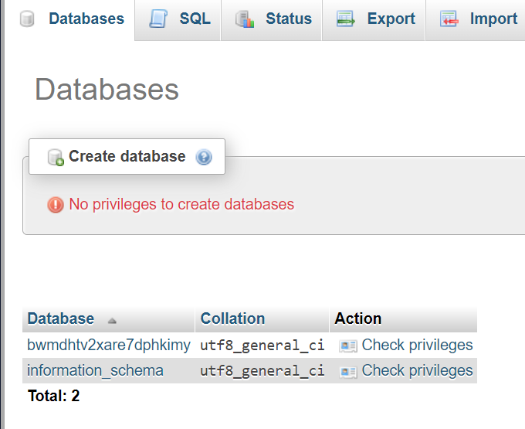

**Create Table:**

**Through SQL script**

* Click on the "SQL" tab in PHPMyAdmin.
* Enter the SQL command to create a table with two columns: one for the file name and another for the file itself.

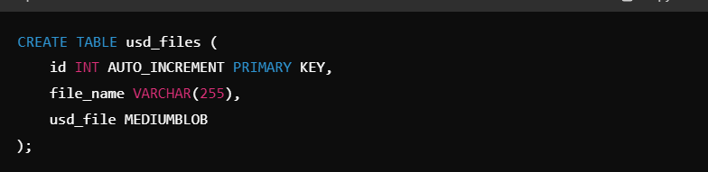

* Adjust VARCHAR(255) and MEDIUMBLOB as needed based on your requirements.

Creating Table without SQL:

**Create Table:**

* Click on the "Structure" tab at the top.

**Add Table:**

* Click on the "Create table" button (usually located near the top-left or bottom-left, depending on PHPMyAdmin version).

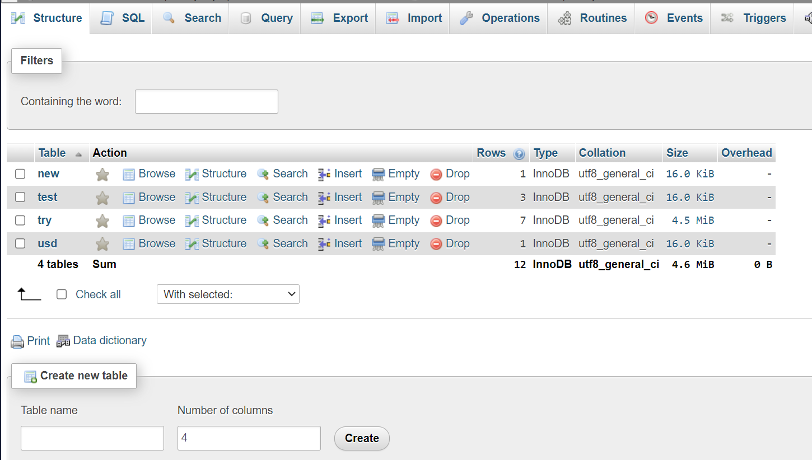

**Define Table Structure:**

* Enter a table name, e.g., usd_files.
* Under "Number of columns," enter 2 (since you want two columns).

**Add Columns:**

For the first column:

* + **Name:** file_name
  + **Type:** VARCHAR
  + **Length/Values:** 255 (adjust as needed)
  + Leave other settings as default or adjust based on your requirements.

For the second column:

* + **Name:** usd_file
  + **Type:** MEDIUMBLOB
  + This column will store the actual USD file as binary data.

**Save the Table:**

* Click on the "Save" button to create the table.

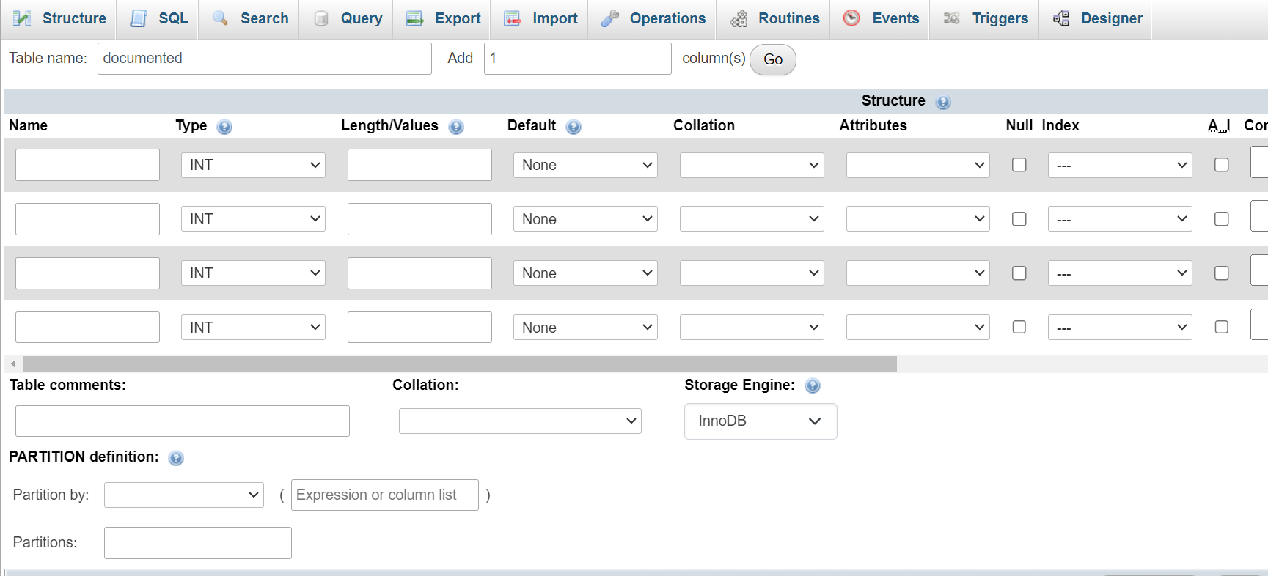

**Import USD File:**

* 1. Go to the "Import" tab in PHPMyAdmin.
  2. Choose the USD file you want to import. If it's in ZIP format, PHPMyAdmin can handle that directly.
  3. Ensure the file is imported successfully.

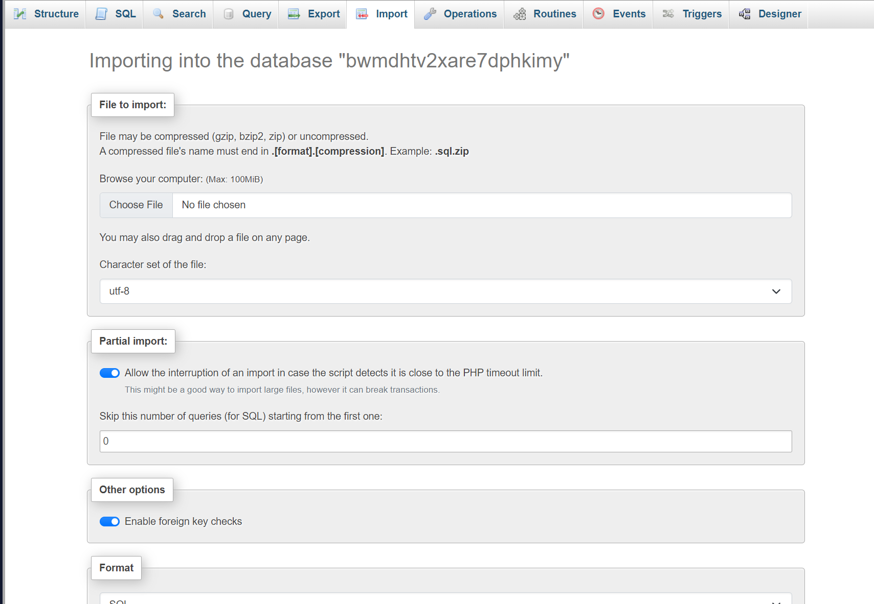

### Understanding BLOB (Binary Large Object)

* **BLOB** is a data type used to store large binary data (like files) in databases. There are different sizes of BLOBs (TINYBLOB, BLOB, MEDIUMBLOB, LONGBLOB) depending on the maximum size of data you expect to store.
* **Importance**: BLOBs are crucial for storing files (such as images, documents, or in this case, USD files) directly in the database alongside other structured data. This ensures all related data is kept together and can be managed within the database system.

### Using the Imported USD File in Unreal Engine

**Download the USD File from Database:**

* + After importing, navigate back to your database and locate the usd_files table.
  + Find the record corresponding to your imported USD file.

**Download the File:**

* + Download the file from the database. It might initially download as a binary (.bin) file.

**Rename and Use in Unreal Engine:**

* + Rename the downloaded file with a .usd extension (e.g., imported_file.bin to imported_file.usd).
  + Import this USD file into Unreal Engine for use in your projects.

Author : DEV SONI